Transcript of the teachings by Geshe Chonyi

Root text: Middle Length Lam-Rim by Lama Tsongkhapa, with additional outlines by Trijang Rinpoche, translated by Philip Quarcoo; Penultimate Edition, May 2008. Copyright: FPMT, Inc. May 2008.

The additional outline and any further additions by Trijang Rinpoche are in small letter type, to be distinguished from Lama Tsongkhapa’s own outline that is in larger letter type.

All page references refer to the root text, unless otherwise stated.

Lesson No: 20 Date: 25th August 2011

We are now at the outline, “How to take the essence” which has two parts:

2B4B-2 How to take the essence: the three beings’ mode of applying the path

A Generating certainty with regard to the general presentation of the path

B The actual way of taking its essence (Page 43)
We will base our discussion on the chart given (see below).

2B4B-2A Generating certainty with regard to the general presentation of the path

1 How all the Buddha’s teachings are contained in the paths of the three [types of] beings

2 Giving reasons for gradual guidance from the point of view of the three [types of] beings

2B4B-2A1 How all the Buddha’s teachings are contained in the paths of the three [types of] beings

A How the meaning of all the excellent teachings [of the Buddha] is subsumed under the accomplishment of two objectives (Page 43)
The Buddha gave a variety of teachings. While he was on the path, he worked hard to accumulate the collections of merit and wisdom for a very long period of time, three great countless eons. Why did he do that? Who was he doing this for? He accumulated the collections of merit for us sentient beings in order to achieve full enlightenment for our benefit.

How does the Buddha benefit sentient beings? Remember the statement, “The Buddha liberates by teaching suchness”? He benefits sentient beings primarily by giving teachings. All the Buddha’s teachings are included in the paths of the three types of persons.

The goals of sentient beings can be categorised into: (1) the provisional goal and (2) the final goal. The provisional (or temporary) goal is high status, i.e., a good rebirth. The final (or ultimate) goal is the definite goodness of liberation and full enlightenment. Therefore when the provisional and final goals are elaborated, there are three goals.

All the Buddha’s teachings are meant for sentient beings to achieve either the goals of high status, liberation or full enlightenment. These are the three goals that are achievable. As such, in terms of the persons achieving these goals, it can be categorised into three types of persons:
- The person of small capacity
- The person of medium capacity
- The person of great capacity

B How lesser beings attain high status (Page 43)
In general, the person of small capacity refers to:
- those seeking only the happiness of this life
- those seeking the happiness of future lives.
In this context, the person of small capacity is not referring to the first type, those seeking only the happiness of this life. The person of small capacity referred to here is the person of genuine small capacity, which is the second type, those seeking the happiness of future lives.

In order to be a person of small capacity, you need to have the interest in seeking the happiness of future lives. But that alone is not enough. In order to be a person of small capacity, you must also have entered an unmistaken path that will help you to achieve the happiness of future lives.

A person of genuine small capacity is someone who is strongly motivated to achieve the goal of high status, good rebirth, and also actively creating the causes to achieve that goal. Although the path of the person of genuine small capacity involves many practices, the primary practices are:
- Going for refuge to the Three Jewels
- Practising the morality or ethics of intentionally avoiding the ten non-virtuous actions
These practices also have to be done by a person of great capacity. These practices then are the path that is shared with the person of small capacity.

What then is the unshared path? The path of a person of great capacity is the path that is unshared.

Question to students: Is there an unshared path of a person of small capacity?

(Various answers from students)

Student: Yes. The aspiration to only achieve a good future rebirth.

Khen Rinpoche: Good. You say that, by practising the ethics of avoiding the ten non-virtues with the specific intention of only achieving a good rebirth, that is the unshared path of the person of small capacity? Yes, it is.

Why? This is because the persons of medium or great capacity do not practise such a path to achieve a good rebirth alone. In the earlier section of the greatnesses of the Lam-Rim teachings, it is mentioned that the person of great capacity who is practising the Mahayana path must also practise the Hinayana path but need not necessarily practise everything that is included in the Hinayana path. What is the illustration that is given in the text?

Student: The aspiration for liberation alone

Khen Rinpoche: Yes. From this you can see that you should not feel satisfied, thinking that you know the subject after having just studied the subject matter once. If you think like this, that is a mistake. You should not be satisfied just looking at the text once but you should read it over and over again because there will be always be things that you have not yet fully understood. In order to highlight this point, that is why I am asking questions in class. These questions are aimed at those who have studied in the past and are not directed at those who have not done the Basic Program.

A person of genuine small capacity has a very strong interest to achieve the high status of a good rebirth. He engages in an unmistaken method to achieve this goal. This method is primarily going for refuge to the Three Jewels and living an ethical way of life, intentionally avoiding the ten non-virtuous actions. What is the result of his practices? It is high status, a good rebirth.

C How intermediate beings achieve the certain goodness of liberation (Page 43)
Next, we look at the person of medium capacity who only seeks to achieve liberation from cyclic existence. He is someone who is disenchanted with cyclic existence and has the feeling of definitely wanting to get out of it. With this motivation, this person engages in the method that will lead him to achieve liberation from cyclic existence.

What does he need to do in order to achieve this goal? First, he needs to generate renunciation, the determination to be freed from samsara. On that basis, he needs to practise the three higher trainings. This is the training of a person of genuine medium capacity.

Generating the thought of renunciation and practising the three higher trainings also constitute the path that is shared with a person of medium capacity. This is something that a person of great capacity would also need to practise. Therefore it is shared.

If there is a path that is shared with the person of medium capacity, then there must be also an unshared path of the person of medium capacity. The unshared path would be generating the thought of renunciation and practising the three higher trainings with the intention of achieving only liberation from cyclic existence. By putting these into practice, the person of medium capacity will achieve liberation from cyclic existence.

The Hinayana path can be divided into two: (1) the path of the hearers and (2) the path of the solitary realisers. With regard to the liberation that is achieved, you can also posit two Hinayana liberations: (1) the liberation that is achieved by the hearers and (2) the liberation that is achieved by the solitary realisers.

The details of the Hinayana path, the hearers’ path and the solitary realisers’ path and their differences will be covered in future modules such as Buddhist tenets.

D How great beings attain omniscience (Page 44)
Next, we look at a person of great capacity who, motivated by great compassion and concern for sentient beings and being unable to bear their suffering, wishes to free them all from their sufferings. In order to achieve that, this person aims to achieve the state of full enlightenment, buddhahood.

In order to achieve this goal of full enlightenment, the person of great capacity cultivates the Mahayana path, the method for achieving the state of full enlightenment and engages in the practice of the six perfections and the yoga of the two stages.

The Mahayana path can be divided into two:
- the Perfection Vehicle (Paramitayana)
- the Mantra Vehicle (Vajrayana)
In order to achieve full enlightenment, you need to enter the Mahayana Path. From the chart, you can see that there are three different Mahayana Paths:
- the path of the Perfection Vehicle
- the path of the three lower tantras
- the path of Highest Yoga Tantra
These are the three different Mahayana approaches.

Let us look at the person who is on the path of the Perfection Vehicle.

What does he practise?
- First, he develops bodhicitta, the altruistic intention.
- Then he generates the wish to achieve enlightenment that comes with a commitment.
- He then takes on the engaged bodhisattva vows.
- He trains in the six perfections
These are the stages of a person who is on the path of the Perfection Vehicle. By depending on the union of method and wisdom, this person will achieve full enlightenment. The Perfection Vehicle is a method to achieve full enlightenment but it is a path that requires the accumulation of the collections of merit and wisdom over, generally speaking, a very long period of time, three great countless eons.

The Mahayana path of the three lower tantras is also a path to achieve enlightenment. The main practice of the Mahayana path of the three lower tantras is to cultivate the two yogas: (1) the yoga with signs and (2) the yoga without signs.

In order to be able to do these practices, that person must receive the great initiation of the relevant class of tantra. Before receiving the initiation, the person must take the bodhisattva vows.

In the three lower tantras, there is no mention of achieving enlightenment in one lifetime in one body. Nevertheless, it is a path that is much quicker than the Perfection Vehicle. While on the path of the three lower tantras, you need not take three great countless eons to complete the accumulation of the collections of merit and wisdom because there are special methods that speed this up.

Then you have the path of Highest Yoga Tantra that is also a way to achieve enlightenment. In order to enter and practise this path, you have to receive the relevant initiation and take and abide by the bodhisattva vows and the tantric vows. On that basis, you engage in the practices of the two stages:
- the generation stage
- the completion stage
Through these practices, you then achieve full enlightenment.

The path of Highest Yoga Tantra is a method to achieve enlightenment that is much quicker than the path of the three lower tantras. It is said that you can achieve the state of full enlightenment in one lifetime and in one body by depending on the path of the Highest Yoga Tantra. In the path of the Highest Yoga Tantra there are special methods on how to quickly accumulate the collections of merit and wisdom.

I am giving you this short explanation because we are now at the outline, “Generating certainty with regard to the general presentation of the path(Page 43).” This is to give you a rough understanding of the whole scheme of things. In order to be able to go into the details of what I have just explained, you need to finish the entire Basic Program!

Question: Can someone who has entered the path of the three lower tantras switch to another path?

Answer: When you do not have an overall understanding of all the treatises and you hear this explanation, you may run into some difficulties. In response to your question, we can say that after you have entered the path of the three lower tantras, you can switch over to the path of the Highest Yoga Tantra and achieve enlightenment. It is definitely possible.

The path of the Perfection Vehicle is a Mahayana Path that can lead you to enlightenment. You can achieve enlightenment by depending on this Vehicle. But from the perspective of Highest Yoga Tantra, by depending on the path of the Perfection Vehicle alone, you cannot achieve enlightenment. You must practice tantra and, within the four classes of tantra, you must definitely practise Highest Yoga Tantra.

When you do not have an overview of the entire framework of all the different scriptures that may be difficult to understand. You may think, “How can that be?”

This is something that you will come to ascertain slowly. You need to continue to study the different modules of the Basic Program and through studying, discussing, analysing and investigating them, only then will you be able to arrive at some kind of conclusion or ascertainment.

Question: How does renunciation of the present life fit into the path of a person of small capacity who intends to achieve high status?

Answer: The primary goal of the person of small capacity is the happiness of future lives as he considers that more important than the happiness of this life. Comparing the happiness of this life and the happiness of future life, he emphasises the happiness of future lives because he is seeking another good rebirth. As such the person of small capacity does not renounce the happiness of this life completely. He does consider the happiness of this life as important but he does not place as much emphasis on this as he is focusing on achieving the happiness of future lives.

Question: The Tibetan masters talked about renouncing the eight worldly concerns. How does this fit into the picture for someone who is intent on cultivating the high status?

Answer: Yes, the practice of reversing the attraction to this life is the practice of a person of small capacity because he is primarily interested in the happiness of future lives. He places more importance on the happiness of future lives than the happiness of this life.

But what interferes with putting more emphasis on the happiness of future lives? They are the eight worldly concerns. Therefore in order to be able to place more emphasis on the happiness of future lives you have to do something about the eight worldly concerns. That falls under the practice of reversing the attraction to this life. There are different methods for doing that.

Question: Can I say that it is subsumed under going for refuge to the Three Jewels? By having this mind set, automatically you are reversing the attraction to the current life?

Answer: Yes, you have to reverse the attraction, to get rid of the preoccupation with the happiness of this life alone. There are ways to overcome that and you need to strive in those methods. You are afraid of the sufferings of the three lower realms. You have the faith that the Buddha, Dharma and Sangha can protect you from the sufferings of the lower realms. This is what constitutes the refuge for the person of small capacity.

In order to have refuge, you need to be afraid of suffering. As you don’t want to suffer in the lower realms, the fear of the lower realm means you want a good rebirth. Isn’t the goal of a person of small capacity a good rebirth? So in order to be able to achieve that good rebirth, that person must first weaken his current preoccupation with the happiness of this life alone. If he does not do that, then there is no way for him to achieve that good rebirth.

It is in this context, therefore, that there is a need to reduce the preoccupation with the happiness of this life alone. It is for this reason that there is the meditation on death and impermanence.

When you start the actual practice of the Lam-Rim, one of the very first meditations is the reflection on death and impermanence. That is the method to reduce the current preoccupation with the affairs and happiness of this life alone.

One of the main reasons why there is such a strong preoccupation with the happiness of this life alone is basically the innate feeling that everything will remain constant and will not change. This is called the apprehension of permanence. In order to overcome this, there is the meditation on death and impermanence.

Question: Is there any difference between:
- the higher training in ethics and the perfection of ethics,
- the higher training in concentration and perfection of concentration, and
- the higher training in wisdom and perfection of wisdom?

Answer: Yes, there is. Just having the wisdom realising emptiness doesn’t make it a perfection of wisdom. In order for it to be a perfection of wisdom, it must be conjoined with bodhicitta whereas the higher training in wisdom need not necessarily be conjoined with bodhicitta.

Question: In one of the ten endowments, being born in the central region means that one is born in an area where the four types of followers are active. Who are they?

Answer: What is the criterion for saying that the Buddha’s teachings exist in the world? There are three scriptural collections: the vinaya, the sutras and the Abidharma. The Buddha’s teachings are said to exist in this world if the higher training in ethics exists. Whether the teachings exist in the world or not depend on whether the higher training in ethics exists or not.
In order for the higher training in ethics to exist, there must be practitioners who practise it. The main practitioners are the ordained persons. I think that the four types of person refer to the fully ordained monk, the fully ordained nun, the novice monk and the novice nun.

Question: When does a practitioner acquire the name of a person of medium capacity and when does he acquire the name of a person of great capacity? Is it when he enters the respective paths or is it right from the very beginning when he starts to practise?

Answer: When he develops the uncontrived aspiration for liberation.

Question: Will that be the point when there is the wisdom arising from reflection, when ascertainment of that (aspiration for liberation) arise?

Answer: In order to be a person of medium capacity, you need to have developed an uncontrived aspiration for liberation. This uncontrived aspiration for liberation must be preceded by hearing, reflection, and meditation.

Student: In that case, you can’t call him a person of medium or great capacity from the outset.

Answer: I think in order to be a person of medium capacity, you would have developed an uncontrived aspiration for liberation. If you are a person of great capacity, you would have developed uncontrived bodhicitta. That means you would have the relevant realisations.

Otherwise, when you call yourself a person of one of these three capacities, I am not exactly sure whether that works or not. You are here to study, to reflect and to meditate with the intention of wanting to achieve full enlightenment. I guess you can call yourself someone belonging to the type of person of great capacity but I don’t think you can call yourself a person of great capacity. I don’t know. You can think about this. I am not sure.

Translated by Ven. Tenzin Gyurme
Transcribed by Phuah Soon Ek and Vivien Ng
Edited by Cecilia Tsong
Checked by Shirley Soh
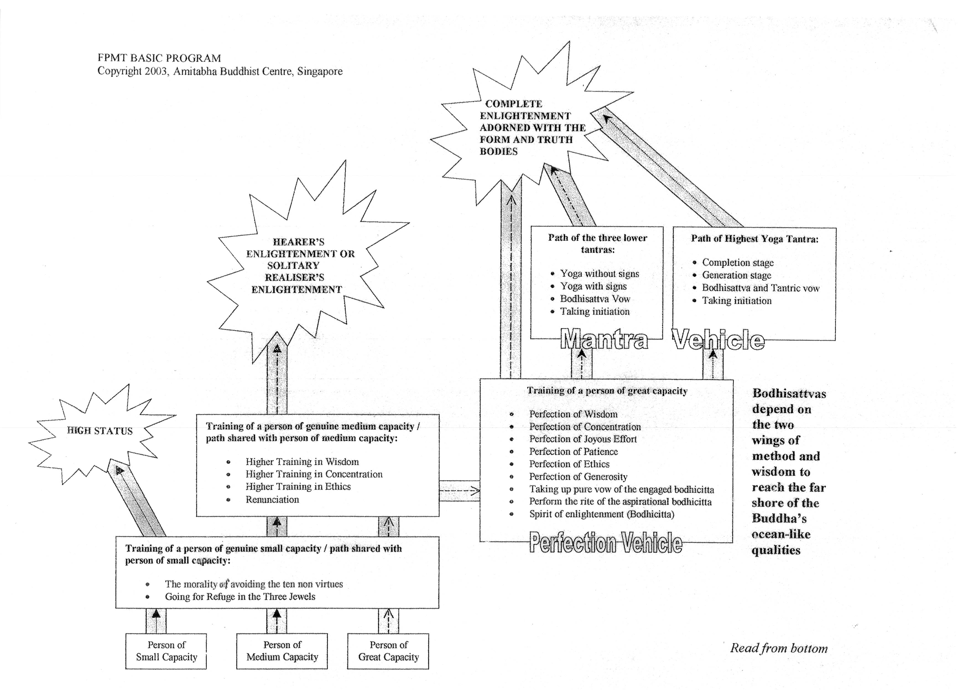

Shared and unshared paths are also translated as common and uncommon paths respectively.

